**King Salman Relief Hackathon: AI in Humanitarian Relief**

**Hosted by:** Alfaisal University

**Event Dates:** February 24-25, 2025

**Format:** Online Mentorship and In-Person Hackathon

**Proposed Website:** <https://ksrhackathon.alfaisal.edu/about> *“This website is currently under development and will go live soon.”*

**Executive Summary**

**Executive Summary**

The **King Salman Relief Hackathon** is a collaborative initiative hosted and designed by Alfaisal University to leverage AI-driven solutions for addressing critical humanitarian challenges in healthcare. The event focuses on three core tracks: AI, healthcare, and innovation, aiming to foster impactful solutions aligned with Vision 2030 that will be adopted and implemented in real-life humanitarian scenarios.

**Key Highlights:**

1. **Roles and Responsibilities:**
   * **Alfaisal University**: Hosting and designing the hackathon, sponsoring the awards, technical training and online workshops, logistics, and mentorship.
   * **Humanitarian Relief Partners**: Screening applications, mentoring participants, and selecting finalists and winners.
2. **Event Timeline:**
   * Spanning from **December 16, 2024**, to **February 25, 2025**, with key activities including application screening, online workshops, and a two-day hackathon event.
3. **Outcomes:**
   * Development of actionable AI solutions and recognition of top projects for their humanitarian impact.

*This package provides a clear strategy, timeline, and responsibilities to guide all partners in making the event a success.*

**Cover Letter/Introduction**

Dear Partners and Teammates,

We are thrilled to collaborate with your organization on the **King Salman Relief Hackathon: AI in Humanitarian Relief**, hosted by Alfaisal University in partnership with King Salman Relief.

This initiative is designed to foster innovative solutions for pressing humanitarian challenges while promoting collaboration between technical and humanitarian experts. Alfaisal University will handle the technical components, including AI, innovation, and healthcare, while your expertise will guide the humanitarian aspects of the event.

Please find the full plan, timeline, and roles in the attached document. We look forward to working together to inspire impactful solutions and align with Vision 2030 goals.

**Sincerely,**

**Noor Al-Saadoun**

**Director Healthcare and Biotech innovation**

**Alfaisal University**

### ****Table of Contents****

1. **Overview**
   * Event Title: King Salman Relief Hackathon: AI in Humanitarian Relief
   * Host: Alfaisal University
   * Format and Event Dates
2. **Executive Summary**
   * Key Objectives
   * Roles and Responsibilities
   * Expected Outcomes
3. **Problem Statement**
   * Challenges in Humanitarian Healthcare
   * AI-Powered Solution Areas
4. **Eligibility and Application Process**
   * Who Can Apply
   * Team Requirements
   * Application Rules and Deadlines
   * Invitation Process
5. **Hackathon Phases**
   * Phase 1: Application and Selection
   * Phase 2: Engagement and Development
   * Phase 3: Final Screening and Event
6. **Workshops and Mentorship**
   * Workshop Topics and Objectives
   * Proposed Workshop Dates
   * Mentorship Support
7. **Screening and Judging Process**
   * Screening Phases
   * Evaluation Criteria and Guiding Questions
   * Judging Responsibilities
8. **Post-Hackathon Support**
   * Mentorship and Incubation
   * Funding and Collaboration Opportunities
   * Partnerships with Global Innovation Hubs
9. **Letters Included**
   * **Invitation Letter from King Salman Relief Center**
   * **Alfaisal University Announcement Letter**
   * **Mentor and Judge Invitation Letter**
10. **Contact Information**
    * Event Website: [https://ksrhackathon.alfaisal.edu](https://ksrhackathon.alfaisal.edu" \t "_new)
    * Key Contacts for Inquiries:

Noor Alsaadoun --Email: [naalsaadoun@alfaisal.edu](mailto:naalsaadoun@alfaisal.edu)--Cell: (966)554111809

**A) Hackathon Problem Statement**

##### **Problem Statement: Addressing Humanitarian Healthcare Challenges with AI**

###### The Problem

Humanitarian relief organizations, like King Salman Humanitarian Aid and Relief Center (KSRelief), face immense challenges in delivering healthcare during crises such as pandemics, poverty, and political conflicts. These crises often lead to:

* Strained healthcare systems.
* Inefficient resource distribution.
* Logistical obstacles in remote and conflict-affected regions.
* A lack of real-time data for informed decision-making.
* In sufficient accessibility and equity in healthcare delivery.

###### The Solution

Advanced AI technologies provide transformative support to innovators and decision-makers in developing solutions to these challenges. We invite you to develop an AI-powered system that addresses these critical issues, focusing on:

* Crisis prediction and early warning systems.
* Disease modeling to guide healthcare strategies.
* Efficient logistics for healthcare delivery.
* Real-time support for decision-makers in humanitarian organizations.

**NOTE**

We highly encourage you to share your feedback, insights, and suggestions. Your input is invaluable in ensuring that this initiative aligns with its objectives and addresses the critical needs of humanitarian challenges effectively. Please feel free to provide detailed comments or recommendations to help us refine and enhance the problem statement.

### ****B) Application Process and Outreach Strategy****

The King Salman Relief Hackathon is open exclusively to **university students residing in Saudi Arabia** who are enrolled in universities across the Kingdom. This ensures a focus on fostering local talent and aligning with national humanitarian goals. Applications must be submitted through the **online application form** available at [https://ksrhackathon.alfaisal.edu/apply](https://ksrhackathon.alfaisal.edu/apply" \t "_new).

#### **Important Details**

1. **Application Deadline:**  
   All applications must be submitted by **December 31, 2024**. Late submissions will not be accepted.
2. **Eligibility:**
   * Only students currently attending universities **within Saudi Arabia** are eligible to apply.
   * Applications from students residing or studying outside Saudi Arabia will not be accepted.

#### **Invitation Process**

The hackathon will be promoted through a two-pronged outreach strategy:

1. **King Salman Relief Center Invitations:**  
   Official invitations will be sent by King Salman Relief Center to university presidents across Saudi Arabia, encouraging student participation.
2. **Alfaisal University Announcements:**  
   Alfaisal University will promote the hackathon through its platforms, including its website and social media channels, to reach a broad audience and ensure students are informed about the opportunity.

#### **Team Requirements**

* **Interdisciplinary Teams:** Each team must consist of **5 to 7 members**, with representatives from at least two disciplines, such as **medical/healthcare** and **engineering**.
* **Team Structure:** Teams should appoint a **group leader** and a **spokesperson** for communications and presentations.

#### **Rules and Expectations**

All applicants are expected to adhere to the following:

* **Eligibility:** Only students currently residing and studying in Saudi Arabia are eligible.
* **Originality:** Submissions must be unique and not previously entered into other competitions.
* **Professional Conduct:** Teams must maintain a collaborative and respectful environment throughout the hackathon.
* **Mandatory Participation:** Teams must attend all workshops, checkpoints, and final presentations.
* **Confidentiality:** Intellectual property and ideas must remain confidential within the team.

**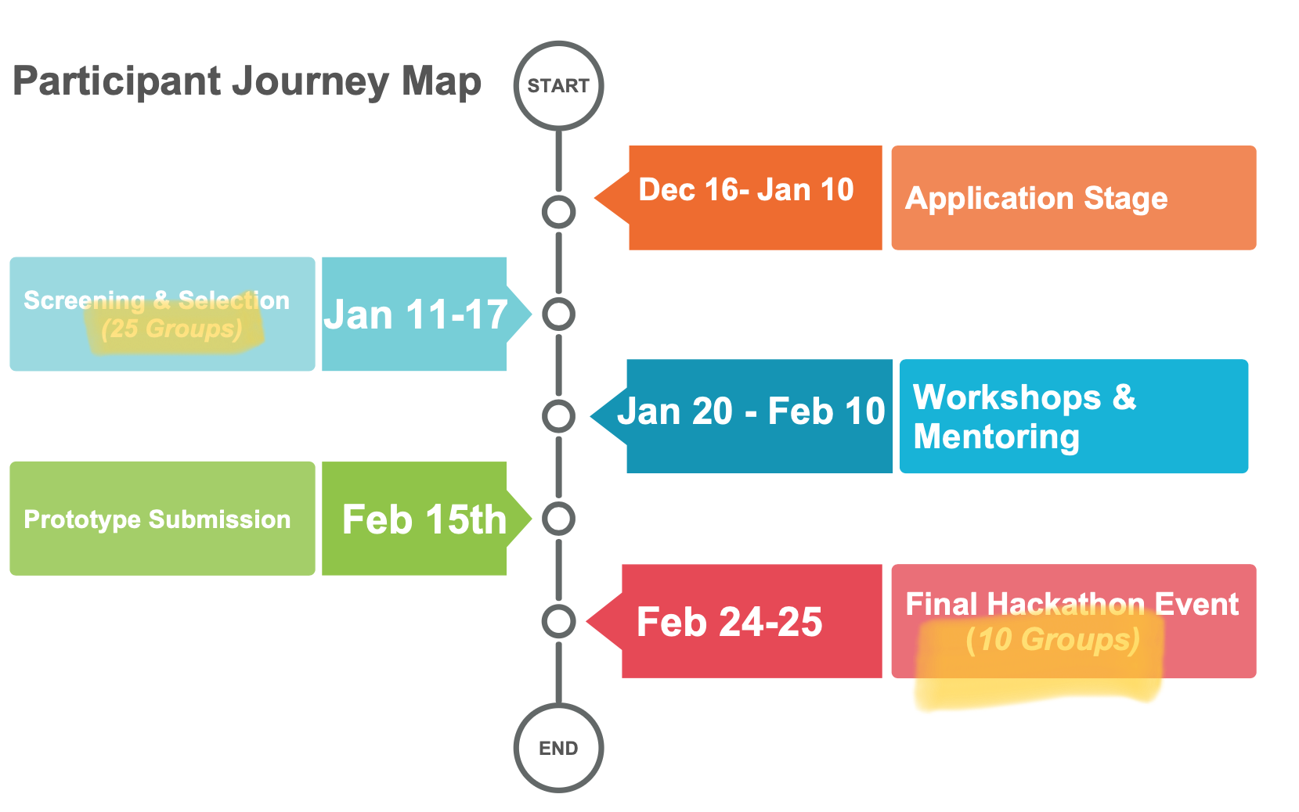**

**C) Hackathon Strategy**

**Hackathon Design Goals**

1. **Foster Innovation:** Develop AI-powered solutions to address humanitarian challenges.
2. **Empower Collaboration:** Bridge technical and humanitarian expertise for holistic solutions.
3. **Support King Salman Relief Center's Vision:** Demonstrate how emerging technologies can advance humanitarian efforts while showcasing Saudi Arabia's role as a global leader in innovation and humanitarian aid.

**Key Milestones**

1. Pre-event preparation (Dec 16, 2024 - Jan 20, 2025)
2. Participant engagement via workshops (Jan 20 - Feb 10, 2025)
3. Prototype submission and screening (Feb 15-20, 2025)
4. On-site mentorship and judging (Feb 24-25, 2025)

**All Activities Conducted Online:**

* + Workshops, mentorship sessions, and all communications will be conducted online, ensuring accessibility and global participation.
  + A detailed guide for accessing Discord and Calendly will be shared with participants before the hackathon begins.

**Phased Timeline of Key Activities**

The timeline consists of **three phases**: **Application and Selection**, **Engagement and Development**, and **Final Screening and Hackathon Event**. The table below outlines key dates, activities, and details for each phase, including application submissions, workshops, prototype evaluations, mentorship, and final judging to select the top winners.

**Phase 1: Application and Selection**

|  |  |  |
| --- | --- | --- |
| **Date** | **Activity** | **Details** |
| **Dec 16, 2024** | Website Launch | Applications open for submission. |
| **Jan 10, 2025** | Application Deadline | Final day for application submissions. |
| **Jan 11-17, 2025** | Phase 1 Screening | Top 25 groups selected by humanitarian mentors. |
| **Jan 20, 2025** | Announcement of Groups | Selected groups are informed. |

**Phase 2: Engagement and Development**

|  |  |  |
| --- | --- | --- |
| **Date** | **Activity** | **Details** |
| **Jan 20 - Feb 10, 2025** | Online Workshops | Weekly sessions on AI, healthcare, and innovation. |
| **Feb 15, 2025** | Prototype Submission Deadline | Participants submit their prototypes for evaluation. |

**Phase 3: Final Screening and Hackathon Event**

|  |  |  |
| --- | --- | --- |
| **Date** | **Activity** | **Details** |
| **Feb 15-20, 2025** | Phase 2 Screening | Top 10 groups selected by humanitarian mentors. |
| **Feb 24, 2025** | Mentorship and Feedback Day | On-site intensive mentorship for finalists. |
| **Feb 25, 2025** | Final Presentations and Judging | Winners selected by humanitarian judges. |

**Workshops Overview**

The workshops are designed to equip participants with essential skills and knowledge to develop impactful AI-driven solutions for humanitarian challenges. These sessions, led by experts, cover **AI fundamentals in healthcare**, **design thinking for innovative solutions**, and **healthcare challenges in crisis scenarios**. To enhance the learning experience, we propose scheduling time for mentors to deliver short talks within these three tracks. These talks will allow mentors to share their expertise, real-world insights, and practical tips, further empowering participants to create innovative solutions aligned with Vision 2030 goals and humanitarian needs.

The hackathon will feature **hands-on coaching sessions** focused on guiding participants in designing their prototypes and developing AI-driven solutions. These sessions will be facilitated by expert mentors and trainers provided exclusively by Alfaisal University, ensuring participants receive high-quality guidance.

During these sessions, participants will work closely with experts to:

1. Refine their problem statements and align them with real-world humanitarian needs.
2. Design effective and practical prototypes tailored to address their selected challenges.
3. Integrate AI tools and techniques into their solutions, leveraging Alfaisal's technical expertise to build scalable and impactful innovations.

These hands-on coaching sessions are structured to provide actionable feedback, ensure progress, and empower participants to deliver well-rounded solutions by the end of the hackathon.

**Proposed Workshop Dates** (Please note that these dates are tentative and may be adjusted.)

|  |  |  |  |
| --- | --- | --- | --- |
| **Date** | **Workshop Topic** | **Lead/Mentor** | **Objective** |
| **Jan 20-27, 2025** | AI Fundamentals in Healthcare | Mohammed Bahloul | Teach AI basics for humanitarian applications. |
| **Jan 27-Feb 3, 2025** | Design Thinking for Humanitarian Solutions | Tarek Mokthar | Foster innovation through design thinking. |
| **Feb 3-10, 2025** | Healthcare Challenges in Crisis | Noor Alsaadoun | Address healthcare-specific humanitarian issues. |

### ****D) Screening and Judging Process****

To ensure the selection of impactful and relevant solutions, the screening and judging processes will involve both technical and healthcare subject matter experts, including representatives from **King Faisal Hospital**, who will provide invaluable expertise in humanitarian healthcare. The process will emphasize selecting solutions that address current and pressing humanitarian challenges.If necessary, we can propose the inclusion of an expert with **AI knowledge** to further strengthen the evaluation of technical aspects.

#### **Screening Evaluation Process**

The evaluation criteria focus on three key aspects to ensure the selection of impactful and feasible solutions. **Relevance to Humanitarian Needs** assesses whether the proposed solution addresses immediate and tangible challenges faced in humanitarian contexts, ensuring it aligns with pressing real-world issues. **Innovation and Creativity** evaluates the novelty and forward-thinking nature of the idea, emphasizing unique approaches that stand out from existing solutions. Finally, **Technical Feasibility** examines whether the solution can be realistically developed and implemented with the available resources and within practical constraints, ensuring its viability for real-world application.

The screening process will take place in two phases:

**Phase 1: Application Screening (January 11-17, 2025)**

During this phase, mentors will carefully review submitted applications to shortlist the **top 25 groups**. The focus will be on evaluating initial ideas and ensuring they align with real-world humanitarian needs.

**Phase 2: Prototype Screening (February 15-20, 2025)**

Once prototypes are submitted, healthcare experts from **King Faisal Hospital** will join the mentors to evaluate the progress and practicality of the proposed solutions. This collaboration ensures a balance between technical feasibility and healthcare applicability. The **top 10 teams** will be selected to advance to the final stage.

**Screening & Judging Scoring**

The screening & judging process will evaluate solutions holistically, ensuring they align with humanitarian priorities and exhibit real-world feasibility. To streamline and guide the evaluation process, the following criteria and corresponding **guiding questions** have been developed:

**1. Relevance to Humanitarian Needs (25%)**

* **Guiding Questions:**
  + Does the solution address a critical and pressing humanitarian challenge?
  + How well does it align with the needs of affected populations or communities?
  + Does the solution reflect an understanding of the humanitarian problem it aims to solve?

**2. Innovation and Creativity (20%)**

* **Guiding Questions:**
  + Does the solution present a novel approach or unique perspective on the problem?
  + How innovative is the integration of AI or other technologies in the proposed solution?
  + Does the solution stand out compared to existing alternatives?

**3. Technical Feasibility (20%)**

* **Guiding Questions:**
  + Can the solution realistically be implemented with the available resources?
  + Does the prototype demonstrate a clear path to development?
  + Are the technical components practical and achievable within the proposed timeframe?

**4. Scalability and Sustainability (15%)**

* **Guiding Questions:**
  + Can the solution be scaled to benefit a larger population or multiple regions?
  + Is the solution designed for long-term impact and adaptability?
  + Are there clear plans to sustain the solution beyond initial implementation?

**5. Impact Potential (15%)**

* **Guiding Questions:**
  + How significant is the potential benefit to the targeted humanitarian challenge?
  + Are there measurable outcomes that demonstrate the solution’s value?
  + Will the solution have a meaningful, positive impact on affected populations?

**6. Presentation Quality (5%)**

* **Guiding Questions:**
  + Was the solution presented in a clear, structured, and engaging manner?
  + Did the team effectively communicate the importance and impact of their work?
  + Was the presentation compelling and easy to follow for a diverse audience?

### ****Mentors and Judges: Summary of Roles and Responsibilities****

To support the hackathon, we require two groups from your organization: **mentors** and **judges**. Each group has specific and essential responsibilities to ensure a smooth and successful event.

#### **Mentors: Screening and Mentorship**

Mentors will be involved throughout the hackathon to guide participants and evaluate their progress. Their responsibilities include:

1. **Screening Applications (Two Phases):**
   * **Phase 1 (January 11-17, 2025):** Review all applications and select the top 25 groups to advance.
   * **Phase 2 (February 15-20, 2025):** Evaluate prototypes submitted by the 25 groups and select the final 10 teams for the hackathon event.
2. **Providing Mentorship:**
   * Act as guest speakers during **online workshops** (January 20 - February 10, 2025) in AI, healthcare, and innovation tracks.
   * Offer **one-on-one feedback and coaching** via an online platform to refine participants' ideas and solutions.
   * Provide hands-on guidance during the **on-site mentorship day** (February 24, 2025) to help finalists prepare their pitches and prototypes.

#### **Judges: Selecting Final Winners**

Judges will focus on evaluating the final outputs and selecting the top teams. Their responsibilities include:

1. **Final Evaluation (February 25, 2025):**
   * Assess presentations and prototypes from the final 10 teams using clear criteria such as relevance, innovation, feasibility, and impact.
2. **Winner Selection:**
   * Select the **top three winning teams** based on scores and deliberation.

### ****Nominations Needed****

We kindly request your organization to provide:

1. **Mentors (3-5 individuals):** For screening, workshops, and ongoing mentorship.
2. **Judges (1-2 individuals):** For the final judging panel.

**Please confirm your nominations at your earliest convenience to facilitate smooth planning and coordination.**

### ****E) Proposed Platform and Communication Tools****

1. **Consultation and Mentorship Platform: Calendly**
   * **Purpose:** Participants can schedule one-on-one consultations and mentorship sessions with Alfaisal experts and Humanitarian Relief Partners based on mentor availability.
   * **How It Works:**
     + Mentors will provide their available slots on Calendly.
     + Participants can view these slots and book a convenient time for a session.
     + This ensures streamlined scheduling and avoids conflicts.
2. **Communication Platform: Discord**
   * **Purpose:** Discord will be the primary communication platform for all participants, mentors, and organizers.
   * **Features:**
     + Dedicated channels for announcements, Q&A, and team discussions.
     + Real-time chat for quick updates and participant queries.
     + Voice channels for live mentoring sessions and discussions.

### ****F) Post-Hackathon Process: Driving Real-World Impact****

The post-hackathon phase ensures that the innovative ideas generated during the event are developed into actionable, impactful solutions.

The top teams will receive **continued mentorship** from Alfaisal University experts and partners, refining their prototypes and addressing challenges in design and implementation. Select projects may also benefit from **incubation opportunities** within Alfaisal University’s innovation ecosystem, offering resources, workspaces, and professional guidance to help scale their ideas.

To enable broader adoption, teams will be introduced to **funding and collaboration opportunities**, connecting them with NGOs, government bodies, and investors aligned with humanitarian innovation. Additionally, partnerships with organizations like the **Berlin WFP Innovation Hub** will provide global exposure, technical expertise, and potential pathways to scale solutions internationally.

This structured post-hackathon process bridges the gap between ideas and implementation, ensuring that the solutions developed create tangible, lasting change in addressing humanitarian challenges.